Vol. IV, #3
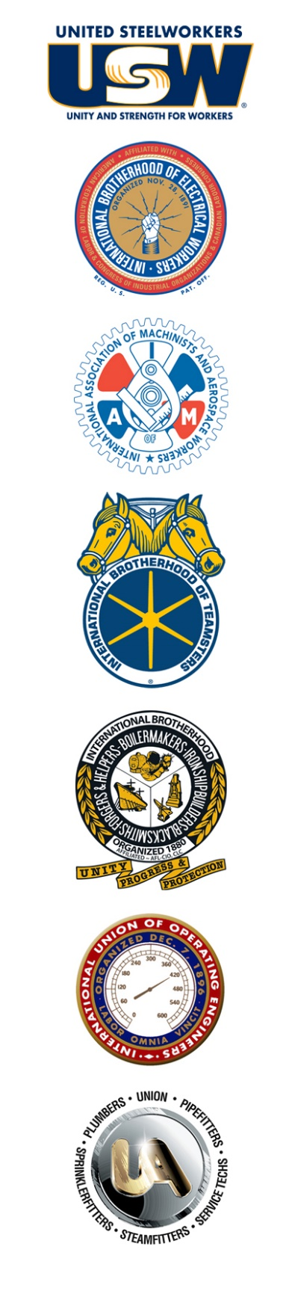
March 28, 2024
Some Progress in Negotiations but Work Still Ahead
The unions and Asarco met again for negotiations on March 25-27, in Mesa, Arizona. The parties made progress via numerous tentative agreements, including improving recall rights and vacation time off, among other items.

Wage increases, health care insurance, profit sharing, and successorship remain unresolved. The USW’s top health care insurance expert joined our union’s team of technicians, lawyers, negotiating professionals and most importantly, your elected local union representatives. Discussions this week were meaningful, but not yet fruitful.

Your Unified Bargaining Committee continued to push hard for resolutions to open items. Both sides passed numerous proposals with significant progress toward an overall agreement. The company shifted from its all-or-nothing approach, and the gap between the parties’ respective wage proposals has narrowed, with movement from both sides.

While Asarco removed some of its most egregious barriers to progress, it continues its ludicrous demand that no wage increases would be guaranteed in the second or third years of the contract. Their proposal would instead provide a lump sum payment of 2.5% in each of these two years. This approach would leave wage rates stagnated and seriously erode workers’ earning power with every passing year.

Adding insult to this injury, Asarco calls their wage rates “minimum rates,” leaving open a unilateral management right to gerrymander wages. Asarco also proposed to eliminate our 6-month bidding procedures going forward.

The parties will be back at the negotiating table next month. In the meantime, let your supervisors and managers know that your resolve to win a fair contract is not fading.

Stand up, fight forward and be safe!

Text ASARCO to 47486 and receive text updates and notifications for every issue of the Solidarity News!

