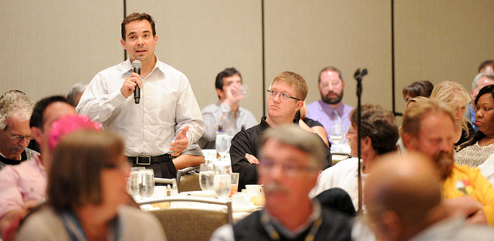

USPA - 50 Years of Telling the Steelworker Story

You are hereby notified that **the Triennial Conference of the United Steelworkers Press Association (USPA)** will be held at the **Wyndham Grand Downtown in Pittsburgh, PA, June 20-24, 2016.**

A reception and registration of delegates and observers will be held Monday, June 20 at 6 p.m. at the hotel. The opening session of the conference is set for 8 a.m. on Tuesday, June 21. In addition to training, we also will be celebrating the 50th anniversary of the USPA.

The USPA welcomes and encourages all United Steelworkers locals that wish to promote local union communications to attend this event. Local unions are welcome to send as many observers as they like, and are encouraged to send members who are participating in the USW’s Next Generation young workers program.

Only USPA members are eligible to be voting delegates who will participate in the election of officers, and to vote on any proposed by-law changes or motions placed before the body. Locals can join the USPA for free by downloading a membership form online.

The program will include workshops, a variety of speakers and a day of action. Official business will also include the election of USPA Executive Board members for terms of office.

USPA delegate discusses media options for locals.

News and Information for Local 1234 of the United Steelworkers Vol. 1  Issue 1

USPA - 50 Years of Telling the Steelworker Story

You are hereby notified that **the Triennial Conference of the United Steelworkers Press Association (USPA)** will be held at the **Wyndham Grand Downtown in Pittsburgh, PA, June 20-24, 2016.**

A reception and registration of delegates and observers will be held Monday, June 20 at 6 p.m. at the hotel. The opening session of the conference is set for 8 a.m. on Tuesday, June 21. In addition to training, we also will be celebrating the 50th anniversary of the USPA.

The USPA welcomes and encourages all United Steelworkers locals that wish to promote local union communications to attend this event. Local unions are welcome to send as many observers as they like, and are encouraged to send members who are participating in the USW’s Next Generation young workers program.

Only USPA members are eligible to be voting delegates who will participate in the election of officers, and to vote on any proposed by-law changes or motions placed before the body. Locals can join the USPA for free by downloading a membership form online.

The program will include workshops, a variety of speakers and a day of action. Official business will also include the election of USPA Executive Board members for terms of office.

You are hereby notified that **the Triennial Conference of the United Steelworkers Press Association (USPA)** will be held at the **Wyndham Grand Downtown in Pittsburgh, PA, June 20-24, 2016.**

A reception and registration of delegates and observers will be held Monday, June 20 at 6 p.m. at the hotel. The opening session of the conference is set for 8 a.m. on Tuesday, June 21. In addition to training, we also will be celebrating the 50th anniversary of the USPA.

**The USPA welcomes and encourages all United Steelworkers locals that wish to promote local union communications to attend this event. Local unions are welcome to send as many observers as they like, and are encouraged to send members who are participating in the USW’s Next Generation young workers program.**

Only USPA members are eligible to be voting delegates who will participate in the election of officers, and to vote on any proposed by-law changes or motions placed before the body. Locals can join the USPA for free by downloading a membership form online.

The program will include workshops, a variety of speakers and a day of action. Official business will also include the election of USPA Executive Board members for terms of office.

USPA - 50 Years of Telling the Steelworker Story